Project Name |  | Confidentiality Level
Contract Project |  | For Recipients’ Reference Only
Project ID | Version | Document Code
BP | 1.0 | Project ID_SD_001

Contract Software System Design Specification

Member: 张瑜 15301024
杜月锌 15301033
韩婉霞 15301037

Revision Record
Date | Revision Version | CR ID /Defect ID | Sec No. | Change Description | Author
2017.5.29 | 1.0 |  |  | Start design | 15301024

Content
1 Introduction 5
1.1 Purpose 5
1.2 Scope 5
1.2.1 Name 5
1.2.2 Functions 5
1.2.3 Applications 5
1.3 Software system context definition 5
1.4 Design Considerations 6
1.4.1 The three-tier architecture of the system is shown below: 6
1.4.2 The development pattern of the program and the three-tier structure 6
1.4.3 A three-layer structure with the package hierarchy of Model 2 6
2 Level 1 Design Description 7
2.1 System Architecture 7
2.1.1 Contract management 7
2.1.2 Query statistics 7
2.1.3 Basic data management 7
2.1.4 System management 7
2.2 Representation of the Business Flow 7
2.2.1 Contract management process: 8
2.3 Decomposition Description 8
2.3.1 sign in 8
2.3.2 Login/log out 8
2.3.3 contract management 9
2.3.4 inquiry statistics 11
2.3.5 Basic Data Management 11
2.3.6 system management 11
2.4 Interface Description 12
3 Database Design 13
3.1 conceptual model 13
3.2 physical model 13
3.3 Database table design 13
3.4 Data Administration 16
4 UI Design 18
4.1 login page 18
4.2 Administrative webpage 18
4.3 Contract drafting page 19
4.4 Contract list page 19
5 Detailed Design 20

Keywords:
Contract Flow Privilege
Abstract:
List of abbreviations:
The specification of the requirements specifications of the department shows the functional structure of the contract management system, the detailed function introduction, the data dictionary and the sex Ability, interface requirements, etc. Through the description of the system use case diagram, the activity diagram and the functional structure diagram, the contract management system is explained Detailed requirements, the system contains user registration, login, contract management, query statistics, basic information management and system administration Can.
Abbreviations | Full spelling | Chinese explanation
MVC | Model-View-Controllor | 模型-视图-控制器
DAO | Data Access Objects | 数据访问对象
B/S | Browser/Server | 浏览器/服务器结构

- Introduction

Purpose
The requirements specification is a description of the functional requirements and performance requirements of the contract management system .
The reader is:
Users;
Project management personnel;
The tester;
Design personnel;
The developers.
The focus describes the functional requirements of the process management and permissions management of two modules, specifying the work that the software should be developed Ability, performance, and interface to enable system analysts and software developers to understand the user's needs clearly.

Scope
    - Name
Contract Management System
    - Functions
Reference to the requirements specification for contract management system
    - Applications
The contract management system begins with the collection of contract basis parameters, contracts and drafts, negotiates with the user, contracts and repairs To make a contract, sign a contract, record the execution of the contract, carry out the contract execution trace management until the contract terminates and run through the contract The whole process.

Software system context definition
The contract management system is a B/S structure, and the system's access structure is as follows:
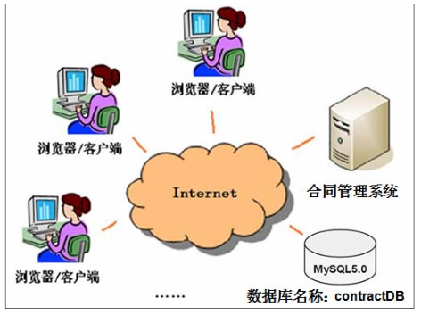

Design Considerations
    - The three-tier architecture of the system is shown below:
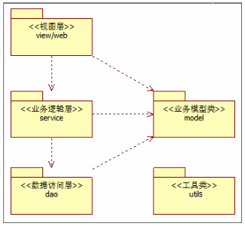
The system is divided into presentation, business logic, data access, Corresponding package : (com.ruanko.web), (com.ruanko.service),(com.ruanko.dao). They invoke the business model class (that is, the com.ruank.model package) The data is passed through, and some of the classes will be Shared, just like tools, and then unify them In the com.ruanko. Utils package.
    - The development pattern of the program and the three-tier structure
The system USES the Model 2 development pattern: JSP + Servlet + JavaBean (MVC), which is combined with the three-tier architecture, The Servlet (controller) and the JSP page (view) act as the presentation layer, and the JavaBean is the model (contains business logic, data access, and industry The business model class, etc., ACTS as the business logic layer and the data access layer.
    - A three-layer structure with the package hierarchy of Model 2
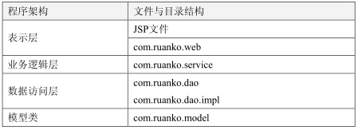
Folder directory
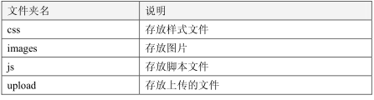
- Level 1 Design Description

System Architecture
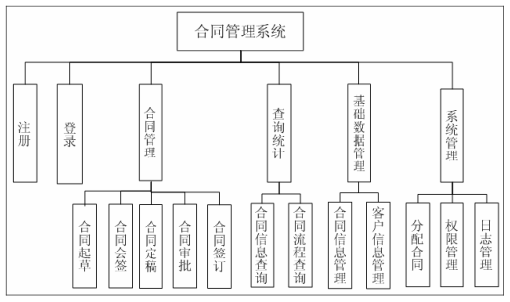
    - Contract management
After the contract operator has logged in, the draft may be drawn up. Click on the pending contract, which you can assign to yourself The contract is to be signed and signed; If you click on the contract, the contract will be finalized. Click on the approval contract The contract shall be subject to examination and approval; Accordingly, the contract can also be signed into operation
    - Query statistics
After the administrator login system, the basic information of the contract can be queried, such as the name and so on. You can also track the process of the contract and the status of the contract
    - Basic data management
When administrators enter the system, they can add, query, modify, and delete customer information. The contract can also be carried out New, query, edit, delete.
    - System management
After the administrator login system, you can assign personnel to the drafting contract and assign permissions to the functional module of the system. In addition, the operation of the database in the system should be set up for operation log, which can be returned with a single or batch operation if necessary In the state, the logging operation is accompanied by the user action function that happens automatically and enters the library.

Representation of the Business Flow
    - Contract management process:
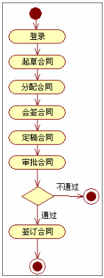

Decomposition Description
    - sign in
1. Functional description
Fill in the registration information on the registration page and ask to fill in the user name (must fill in, 4 ~ 20 Chinese characters, letters, Numbers, or underline The form of a string that cannot be registered with a heavy name), the password (must be filled in, 6 ~ 12 characters), confirm the password (and the password remains) ), register.
When the registration information is submitted, there is a requirement that the user correctly fill in the relevant item when the required item is not completed or incorrect Failing in the registration page displays "failed registration!" It is. When all the information is filled out correctly, the form is submitted and the registration successfully jumps to deng Record the page, and if the program appears exception, jump to the exception page.
2. Functional implementation
The user submits the registration request, and the RegisterServlet obtains the user's registered information from the registration page and invokes the business logic layer The register () method of the UserService handles the registration business.
UserService call the data access layer UserDaoImpl isExist () process validation with the same logic, there is no user with the same The add () method is called to save the user's registration information.
Each layer passes parameters through the entity class User object.
    - Login/log out
1. Functional description
Fill in the user name, password, and click the login button to login. The user name and password cannot be required Empty, for null, gives an error message on the login page. Login page prompts "user name or password error!" ; System exception, jump to the exception page; Log in successfully to the new user page and display the current login user name.
Logged in, click the logon login link on the new user page to clear the user's login status. Return to climb Record the page.
2. function realization
(1) login
The user submits the login request, and the LoginServlet obtains the user login information from the login page and invokes the business logic layer The login () method of the UserService handles the login business.
UserService calls the data access layer userdaoimpl.login () method to query the match user information and return the user number.
(2) log out
LogoutServlet receives the "logon" request for the header of a new user page, removes user information from the session, and jumps Go to the login page.
    - contract management
1. Introduction
After the contract operator has logged in, the drafting authority may be drafted; Click here to sign the contract, You can sign the contract that is assigned to you; If you click on the contract, the contract will be finalized. Click on the Pending the approval contract, the contract may be examined and approved; Accordingly, the contract can also be signed into operation.
2. Feature list
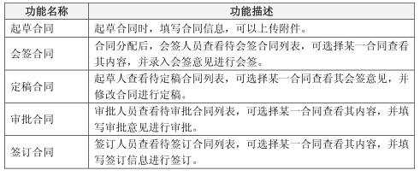
      - draft a contract
1. Functional description
The contract operator fills out the contract name in the drafting of the contract page, starts the time, ends the time, the contract content, the customer, and You can upload the attachment of the contract.
After successful drafting of the contract, the status of the contract is "drafted", waiting for the administrator to assign personnel to the contract.
Status of contract:
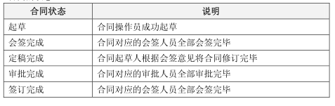
2. Functional implementation
The user drafts the contract, and DraftServlet USES doPost () to handle the user's draft contract request, which is called The draft () method in the ContractService completes the drafting of the contract logic.
In the draft () method, you first generate the Contract number and set it to the Contract to invoke add () assurance in the ContractDao Deposit the contract information, and if the draft is successful, the add () in ConStateDao is called to hold the status information of the contract.
      - countersign a contract
1. Functional description
The visa personnel will look at the list of contract signing contracts, and may select a contract to view their contents and record their comments.
2. function realization
(1) Check the list of "pending" contracts
The people involved click on the "pending contract" hyperlink to the admin page, and the ToDhqhtListServlet gets the query. The getDhqhtList () in the ContractService is called by the doPost () method to handle the query pending contract request.
(2) View the details of the contract
The person who has signed a contract, click the contract name hyperlink, and the ContractDetailServlet gets the query request. The getContractDetail() in the ContractService is called by the doPost () method to handle the query pending contract request.
(3) countersign a contract
For a contract, the clerk clicks the "TAB" hyperlink, and the ToAddHQOpinionServlet gets the query , The getContract() in the ContractService is called by the doPost () method to handle the query pending contract request.
The AddHQOpinionServlet gets the contract when the signing contract is signed and the input is signed and submitted The contract request calls the counterSign () method in the ContractService to handle the signing contract business logic.
      - Finalized the contract
1. functional design description
The draftsman looks at the list of draft contracts, can select a contract to view his written opinion and revise the contract.
2. function realization
(1) Check the list of "pending" contracts
The author clicks on the "pending draft contract" hyperlink for the management page, and the ToDdghtListServlet gets the query request .The doPost () method calls the getDdghtList () in ContractService to handle the request for the pending draft contract.
(2) Check your notes
The author clicks on the "signing opinion" hyperlink to a contract, and the ShowHQOpinionServlet gets the query . The doPost () method calls the The doPost () method calls the getDdghtList () in ContractService to handle the request for the pending draft contract.
(3) Finalized the contract
The drafters target a contract, click the "finalised" hyperlink, and the ToDgContractServlet gets the query request. The doPost () method calls the The doPost () method calls the getContract() in ContractService to handle the request for the pending draft contract.
The DgContractServlet gets the finalized contract when the draftsman enters the contract page and enters the contract content and submits it Ask for the finalize () method in the ContractService to handle the finalized contract business logic.
      - approve the contract
1. Functional description
The examining and approving personnel should look at the list of approved contracts, select a contract to view their contents, and fill in the approval for approval.
2. Functional implementation
(1) View the "pending approval" contract list
The reviewers involved click on the "pending approval contract" hyperlink to the admin page, and the ToDshphtListServlet retrieves the query The request, called getDshphtList () in ContractService, is called by the doPost () method to handle the request for the approval contract.
(2) approve the contract
For a contract, the approver clicks the "approval" hyperlink, and the ToAddSHPOpinionServlet gets the query. called getContract() in ContractService, is called by the doPost () method to handle the request for the approval contract.
The AddSHPOpinionServlet gets the approval when the approver is on the approval contract page, input the approval opinion and submit it The contract request calls the approve () method in the ContractService to handle the approval contract business logic.
      - sign a contract
1. Functional description
Sign a person to look up to sign a contract list, can choose a certain contract to view its content, and fill in signing information to undertake signing.
2. Functional implementation
(1) View the "pending approval" contract list
The people involved click on the "pending contract" hyperlink to the admin page, and the ToDqdhtListServlet gets the query The getDqdhtList () in the ContractService is called by the doPost () method to handle the query pending the contract request.
(2) sign a contract
Signing a contract, click the "sign" hyperlink, and the ToAddQDOpinionServlet gets the query. The getContract()in the ContractService is called by the doPost () method to handle the query pending the contract request.
Sign a contract when signed researchers in page, enter to sign and submit the opinions, AddQDOpinionServlet access request, signing a contract calls ContractService sign in sign a contract () method handles the business logic.
    - inquiry statistics
      - Contract information query
1. Functional description
Paging the contract information according to the contract name.
2. Functional implementation
The administrator clicks on the "contract information" hyperlink to the admin page, and the QueryConInfoServlet retrieves the query request The doPost () method calls the queryContract () in ContractService to handle the query contract information request.
      - Contract process query
1. Functional description
Paging the contract information according to the contract name.
2. Functional implementation
The administrator clicks on the "process query" hyperlink of the admin page, and the QueryProcessServlet retrieves the query request, which is invoked by the doPost () method for queryProcess () in the ContractService to handle the query contract process request.
    - Basic Data Management
      - Contract information management
New, query, modify and delete the contract information
      - client information management
New, querying, modifying and deleting customer information.
    - system management
1. introduction
The administrator can assign contracts, manage permissions, and log management.
2. function list
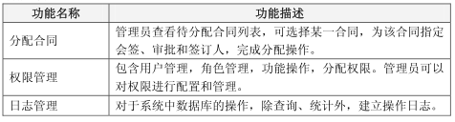
      - assign the contract
1. Functional description
The administrator selects the assigned contract for the "drafting" and specifies the personnel to participate in the signing, approval and signing distribution
2. Functional implementation
(1) Check the list of "pending" contracts
The administrator clicks on the "pending allocation contract" hyperlink to the admin page, and the ToDfphtListServlet retrieves the query request The doPost () method calls the getDfphtList () in ContractService to handle the query to assign the contract request.
(2) assign the contract
The administrator clicks the "assign" hyperlink to a contract, and the ToAssignOperServlet retrieves the query request by calling the getContract () method in the ContractService () method to query the basic information of the contract. Call the getUserListByRoleId () method in the UserService to query the user's basic information.
The AssignOperServlet gets the score when the administrator assigns the contract page, allocates the relevant operator and submits it In conjunction with the request, the distribute () method in the ContractService is called to handle the distribution of the contract business logic
      - authority management
Permissions management includes user management, role management, functional operations, and distribution rights. Administrators can configure permissions And management.
1. functional design description
After the administrator login system, look up the list of users who assign permissions, and then click "authorization" for a user. Hyperlinks to assign user rights pages to assign operations.
2. Functional implementation
(1) View the user rights list
The administrator clicks on the "configure permissions" hyperlink to the admin page, and the ToYhqxListServlet gets the query request by doPost (). The method calls getYhqxList () in UserService to handle the user request for the query to be assigned.
(2) power and responsibility division
For a user, the administrator clicks the "authorization" hyperlink, and the ToAssignPermServlet retrieves the query request The doPost () method calls the getRoleList () method in the UserService to query the role list information.
The AssignPermServlet gets the assigned permissions when the administrator assigns the permissions page, assigns the user role, and submits it Request, invoke the assignPermission () method in the UserService to handle the distribution authority business logic.
      - log management
The operation of the database in the system, the operation log is set up, and the state of the operation before a single or batch operation is necessary.

Interface Description
When using JDBC technology for database access, the Connection, PreparedStatement, and ResultSet interface are mainly involved.
1. JDBC Connection
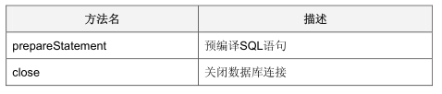
2. JDBC PreparedStatement
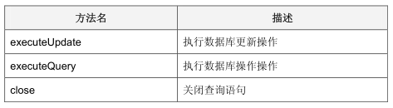
3. JDBC ResultSet
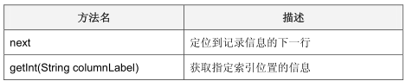
- Database Design
Depending on the requirements and business processes of the contract management system, the system data information may come from interface operations, process processing, Data storage and other processes, the data information involved in these processes is extracted and analyzed, and the project database design is carried out.

conceptual model
The e-r model is used to identify entities, properties of entities, and relationships between entities, according to the data dictionaries sampled Meter.

physical model
The following is a physical model based on MySQL.
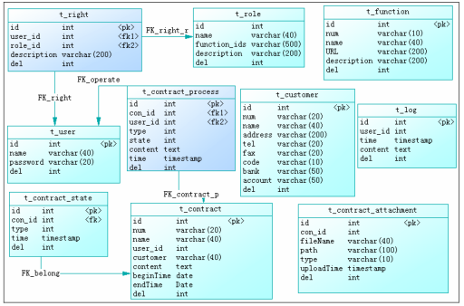

Database table design
1. t_user
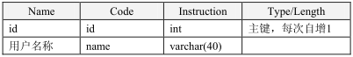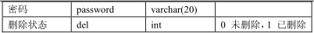
2. t_role
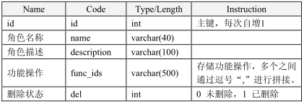
3. t_right
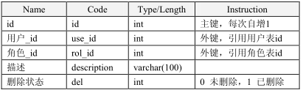
4. t_function
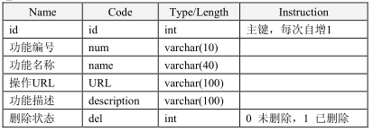
5. t_contract
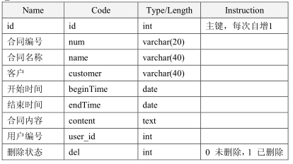
6. t_contract _process
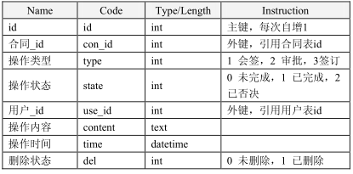
7. t_contract _state
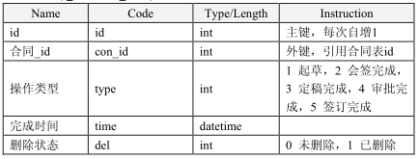
8. t_log
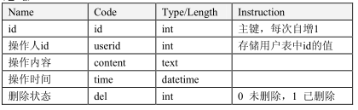
9. t_customer
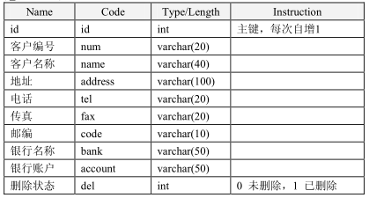
10. t_contract _attachment
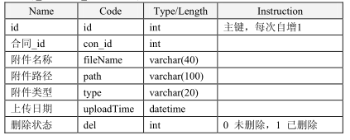

Data Administration
Initialize customer information.
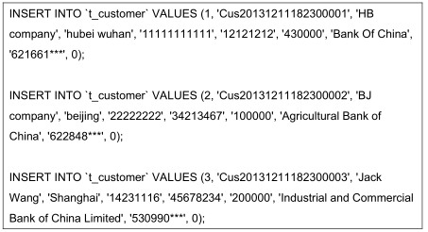
Initialize the functional information.
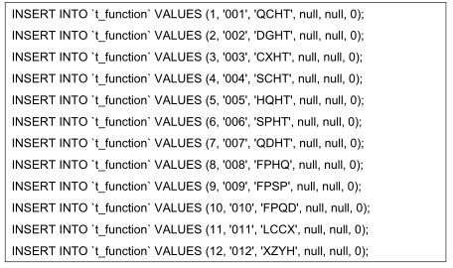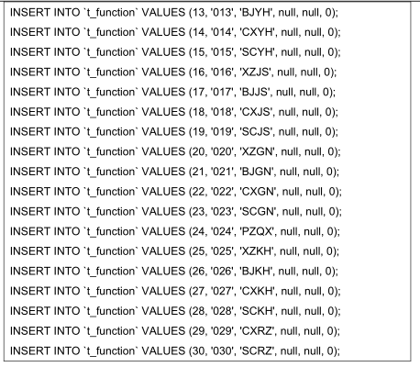
Initialize the role information.
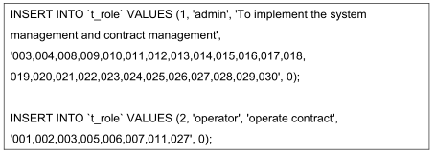
Initialize user information.
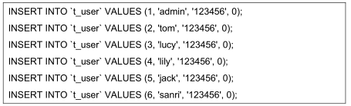
Initialize the permissions information.
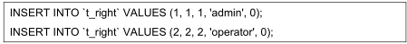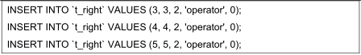
- UI Design
According to the requirements design contract management system as follows:
(1) registration page and login page.
(2) the contract management page.
Drafting, signing, writing, approval, signing, etc. Page, contract details page, contract list page, check the visa Views on the page.
(3) the system administration page.
Assign the contract page, authority management page, and log management page.

login page
1. The original interface
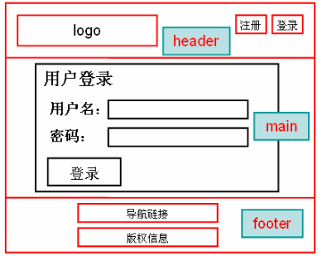
2. Interface specification
The body part is the corresponding form to receive the login information.

Administrative webpage
1. The original interface
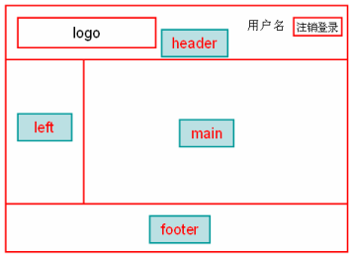
2. Interface specification
The admin page is implemented using the HTML framework web page Frame.
The main body is divided into the left and the right.
Click the management hyperlink on the left and load the corresponding feature page on the right.

Contract drafting page
1. The original interface
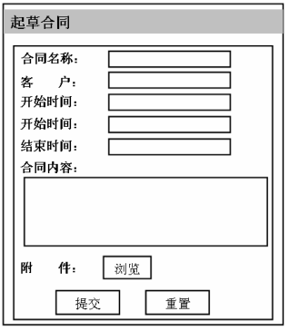
2. Interface specification
The main body is the contract form and USES < table > for layout.

Contract list page
1. The original interface
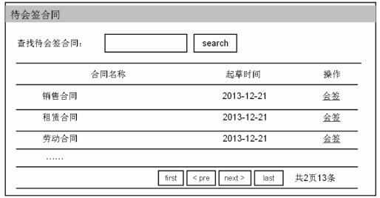
2. Interface specification
To display the contract information in a list, and to query the contract on condition.
- Detailed Design

